PabsonShivraj
Annual Examination 2081
Class : 7 Sub : Maths FM : 50
Time : 2 hrs
- Sets A,B and C are given below.
A={a,b,c}
B={d,e,f}
and C={d,e,f,g,h}
- Define null set with example. (1)
- Write the universal set for all three sets.(1)
- Can we write BCC? Give reason. (1)
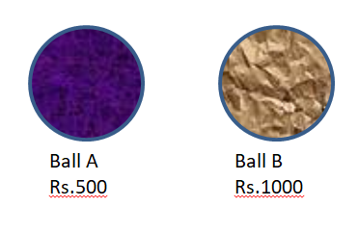
- The cost price of two balls are shown in the figure. A shopkeeper
sold two balls with 10% profit.

- Find the HCFof 500 and 1000. (2)
- How many balls A can be bought in Rs.2000. (1)
- Find the selling price of these two balls. (2)
- If the shopkeeper sold two balls in Rs.2000, how much profit
percent should shopkeeper allowed? (2)
- a. Convert 0.35 into fraction. (1)
b. Simplify : $\frac{3}{4}+\frac{5}{6}-\frac{7}{8}$ (2)
c. Multiply : $2.356×4$ (1)
- Mother divided some money among Ram, Hari and Ganesh in
the nation 2:3:5. Ganesh got Rs.150.
- Calculate the money received by Ram and Hari. (2)
- Find the total amount. (1)
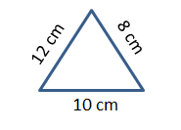
- a. Find the perimeter of given triangle. (1)

b. Find the breadth of cuboid if its volume, length and height are 480 cm³, 10cm and 6cm. (2)
c. If the radius of circle is 7cm.
i. Find its circumference. (1)
ii. Find its area. (1)
- a. What is the value of (2x)º? (1)
b. Simplify : $\frac{x^{a}}{x^{b}}×\frac{x^{b}}{x^{c}}×\frac{x^{c}}{x^{a}}$. (2)
7.If $p+\frac{1}{p}=5$
a. Find$p^{2}+\frac{1}{p^{2}}$. (2)
b. Find the value of ${\left(p-\frac{1}{p}\right)}^{2}.$ (2)
8. A fraction is given below x+y=5.
a. Making x as single. (1)
b. Draw the graph. (2)
9. a. Construct a triangle ABC in which AB=5cm, BC=7cm and ∠ABC =${45}^{o}$.(3)
b. From the given figure, Find the values of x and y. (1)
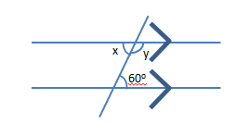
(3x-2)cm
10. Study the following figure,
D
C
a. What is the relation between opposite sides of
60º
parallelogram? (1)
b. What is the value of x? (2)
q
p
c. Find the values of p and q. (2)
(x+4)cm
B
A
11. a. The points A(4,5), B(-2,3), C(6,-7) and D(-8,-9)
are reflected in x-axis. Write the coordinates of image of these points. Also, represent the above relation in graph paper. (3)
b. Find the mid-point (2,3) and (4,5). (2)
c. Write the Pythagoras relation between the sides of right angled
triangle.(1)
12. Class Teacher recorded the number of students in the classes 5 to 7 with boys and girls are as follows.
Classes
Students | 5 | 6 | 7
Boys | 25 | 20 | 30
Girls | 35 | 25 | 25
- How many more students are there in class 5 than the class 7 ? (1)
- Draw a multiple bar diagram of the above data. (2) The End

